Kubernetes installation steps:
Commands:
Use t2.medium and ubuntu 22.04 and allow all traffic on both master and worker nodes
Note: Execute Step 1,2 and 3 on Master node
Execute Step 1 and 2 on Worker node
STEP 1:
sudo su
apt update
swapoff -a
sed -i '/ swap / s/^\(.*\)$/#\1/g' /etc/fstab
--
tee /etc/modules-load.d/containerd.conf <<EOF
overlay
br_netfilter
EOF
--
modprobe overlay
modprobe br_netfilter
--
tee /etc/sysctl.d/kubernetes.conf <<EOF
net.bridge.bridge-nf-call-ip6tables = 1
net.bridge.bridge-nf-call-iptables = 1
net.ipv4.ip_forward = 1
EOF
--
sysctl --system
apt install ca-certificates curl gnupg lsb-release
mkdir -p /etc/apt/keyrings
--
curl -fsSL https://download.docker.com/linux/ubuntu/gpg | sudo gpg --dearmor -o /etc/apt/keyrings/docker.gpg
--
--
echo "deb [arch=$(dpkg --print-architecture) signed-by=/etc/apt/keyrings/docker.gpg] https://download.docker.com/linux/ubuntu $(lsb_release -cs) stable" | sudo tee /etc/apt/sources.list.d/docker.list > /dev/null
--
sudo apt update && sudo apt install -y containerd.io
containerd config default | sudo tee /etc/containerd/config.toml >/dev/null 2>&1
--
sudo sed -i 's/SystemdCgroup \= false/SystemdCgroup \= true/g' /etc/containerd/config.toml
--
systemctl restart containerd
systemctl enable containerd

STEP 2:
apt-get update
apt-get install -y apt-transport-https ca-certificates curl gpg
--
curl -fsSL https://pkgs.k8s.io/core:/stable:/v1.30/deb/Release.key | gpg --dearmor -o /etc/apt/keyrings/kubernetes-apt-keyring.gpg
--
--
echo 'deb [signed-by=/etc/apt/keyrings/kubernetes-apt-keyring.gpg] https://pkgs.k8s.io/core:/stable:/v1.30/deb/ /' | tee /etc/apt/sources.list.d/kubernetes.list
--
apt update
apt-get update

apt-get install -y kubelet kubeadm kubectl
sudo systemctl enable --now kubelet

STEP3:

kubeadm init --pod-network-cidr=10.244.0.0/16
mkdir -p $HOME/.kube
sudo cp -i /etc/kubernetes/admin.conf $HOME/.kube/config
sudo chown $(id -u):$(id -g) $HOME/.kube/config
export KUBECONFIG=/etc/kubernetes/admin.conf
kubectl apply -f https://docs.projectcalico.org/manifests/calico.yaml
kubectl get pods -A
kubectl get nodes

On Master node:
Copy the join command on the master node:
Then you can join any number of worker nodes by running the following command on each worker node as root:
kubeadm join 172.31.40.140:6443 --token 5lz3cq.vgyxjss3qs9djzvv --discovery-token-ca-cert-hash sha256:c8100edbd79952ed5ea6f7ee5fce40b99114c6feca6e7fb8a4c5e9f4b2532a45
Or we can use the below command to get the join command:
kubeadm token create --print-join-command

Note: The join token will be only available on the master and it will be used to map the workers to the master
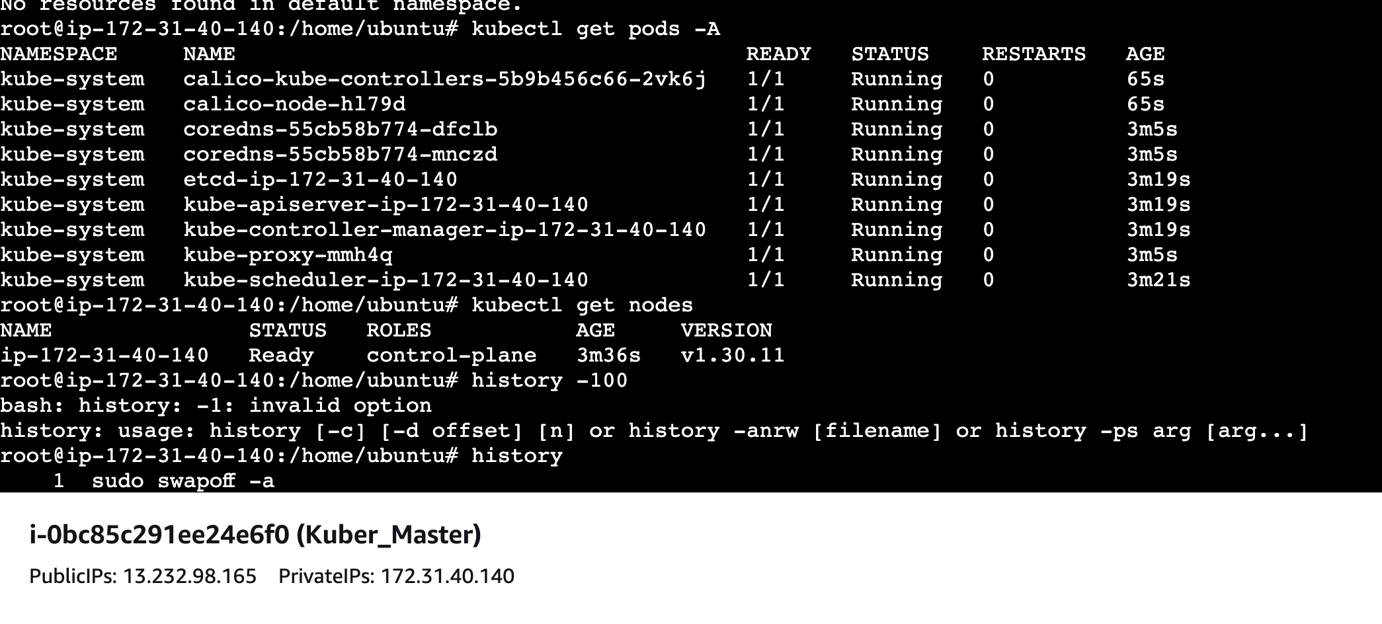

Now we need to connect the worker node with the master node using the join command:
--
kubeadm join 172.31.40.140:6443 --token 5lz3cq.vgyxjss3qs9djzvv --discovery-token-ca-cert-hash sha256:c8100edbd79952ed5ea6f7ee5fce40b99114c6feca6e7fb8a4c5e9f4b2532a45
--
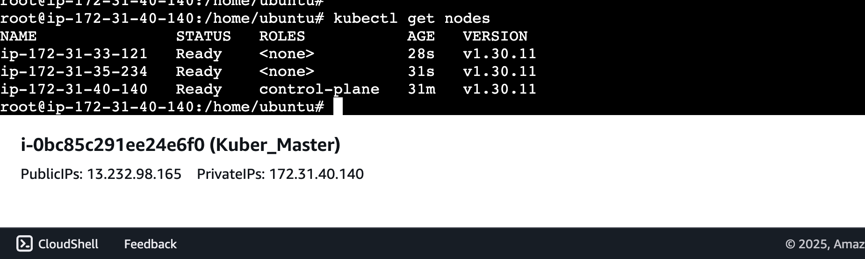

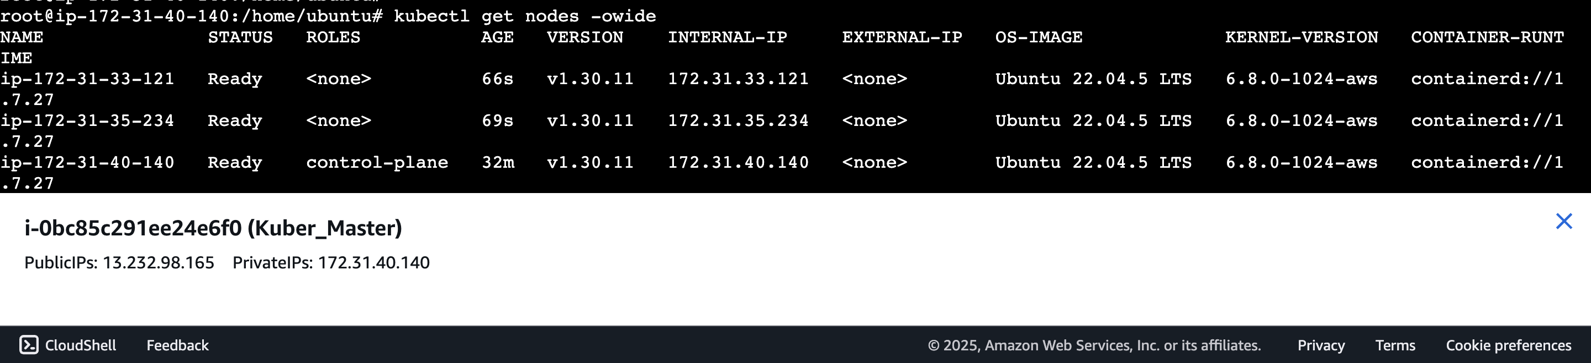
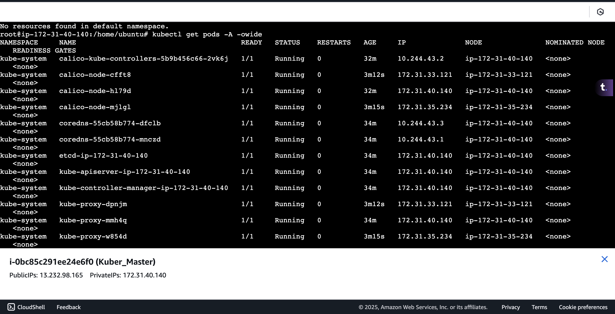

After the reboot/restart of the machine, the config has to be in place
